Computer vision

Homework 01

姓名 ： 蘇宛琳

系所 ： 電信所碩一

學號 ： R05942060

指導教授 ： 傅楸善老師

Computer Vision Report – Homework 01

R05942060 蘇宛琳

* Write a program to generate Image Matching (Detecting Motion Vectors)
  + Detect motions vectors between trucka.im and truckb.im.
  + Use trucka.im as the basis, sample it by an 8x8, 11x11, 15x15, 21x21, 31x31  block.
  + Threshold of search range: 50 pixels. (This is a reference value only!)
  + You must not use any available libraries beyond image I/O (reading or writing  image files from/to the disk/memory).
* 設計原理

Step1 . 將下圖(a)大小為386x386切割成31x31的block，每個block中心為(x,y)。

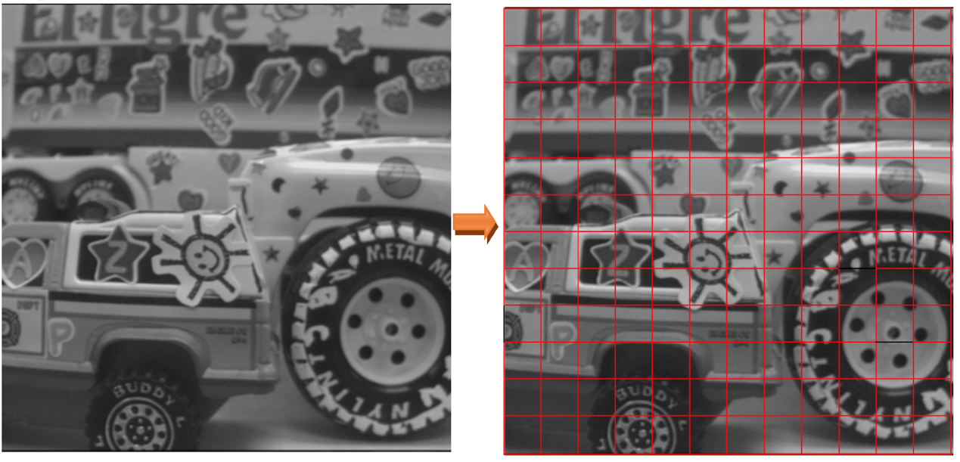

Step2. 假設search range為 50x50，並在圖(b)中以 31x31 的 block，針對圖(a) 中的每個 block，尋找在圖(b)中與圖(a)最相近的 block

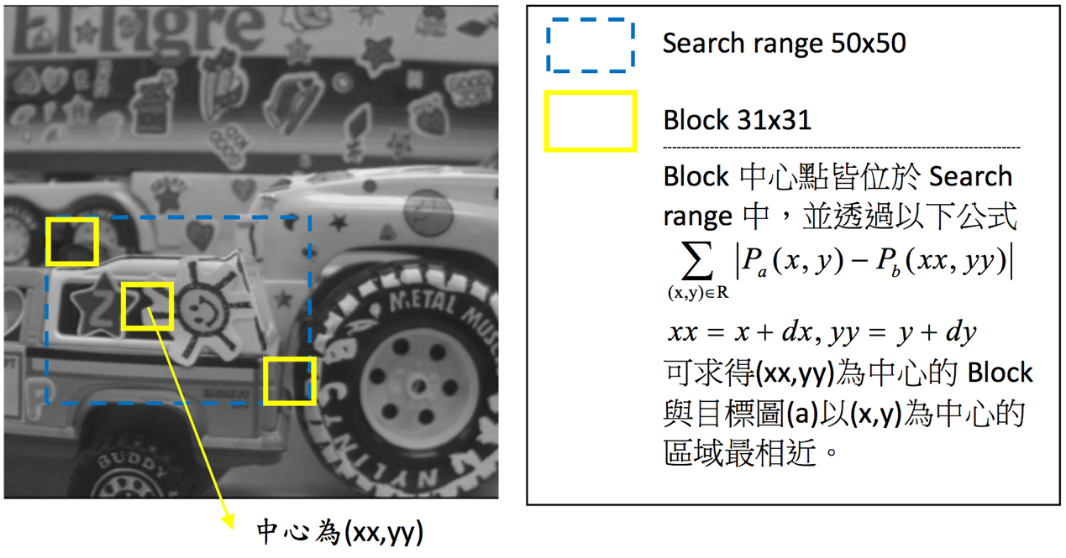

以下兩張圖說明 Step2 的成果。

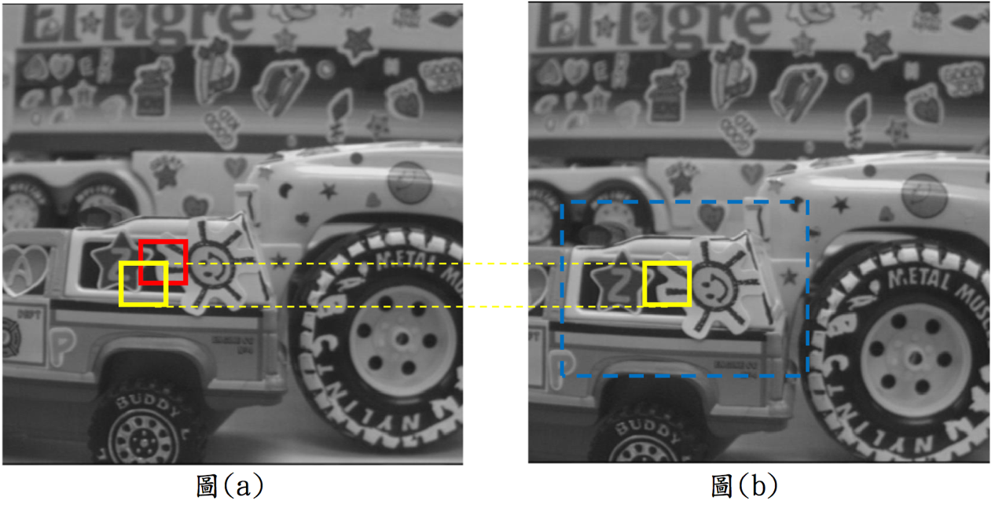

Step3. 接著 Step2 完成後，將圖(a)block 的中心(x,y)與圖(b)block 的中心(xx,yy) 找出兩端點之vector (dx,dy)，將整張圖完成即為最終的成果。

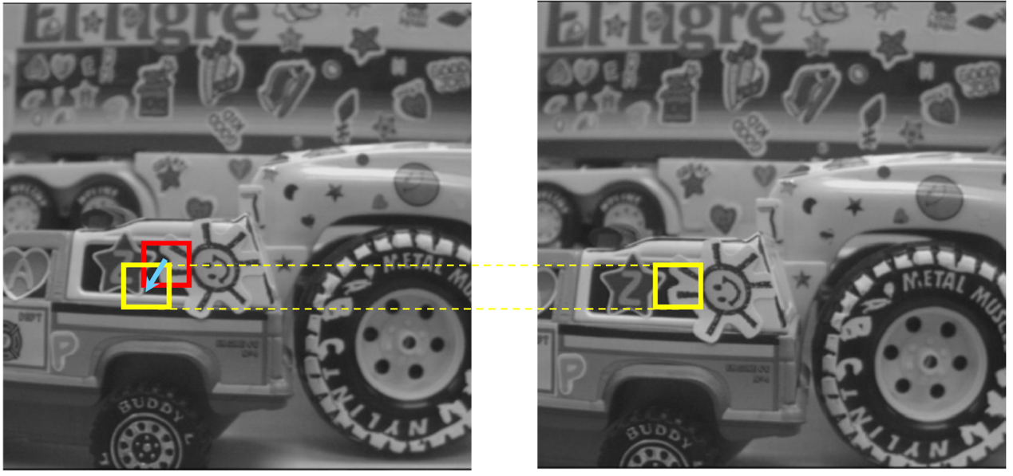

Step4. 可以將 block 做修改，改成 8x8,11x11,15x15,21x21,31x31

* 程式碼

%%%% use correlation to do image matching

a = imread('trucka.bmp');

b = imread('truckb.bmp');

%%%% assume the block is 31x31

a1 = padarray(a,[60 60]);

b1 = padarray(b,[60 60]);

[m,n] = size(a1);

center = 76:31:(9\*31+76);

x = [];

y = [];

xx = [];

yy = [];

for i = 1:length(center)

for j = 1:length(center)

d1 = [];

r1 = [];

c1 = [];

for r = center(i):center(i)+25

for c = center(j) - 25:center(j)

d=sum(sum(abs(a1(center(i)-15:center(i)+15,center(j)- 15:center(j)+15)-b1(r-15:r+15,c-15:c+15))));

r1 = [r1 r];

c1 = [c1 c];

d1 = [d1 d];

end

end

index = find(d1 == min(d1));

x = [x center(i)];

y = [y center(j)];

xx = [xx r1(index(end))];

yy = [yy c1(index(end))];

end

end

dx = xx-x;

dy = yy-y;

figure;

quiver(x,y,dx,dy);

axis([0 m 0 n]);

axis square;

* 實驗結果

Search range : 40x40 ; block : 31x31

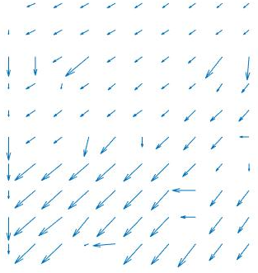

Search range : 30x30 ; block : 21x21

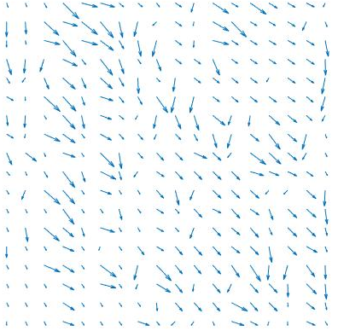

Search range : 30x30 ; block : 15x15

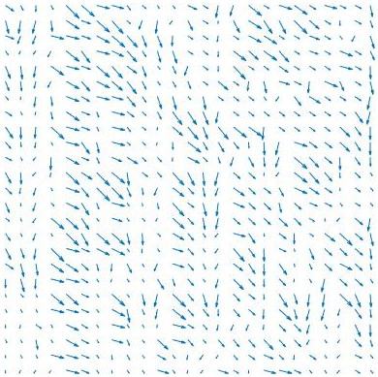

Search range : 20x20 ; block : 11x11

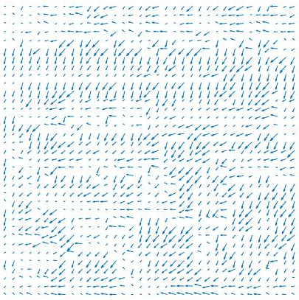

Search range : 20x20 ; block : 8x8

